Charles Essi

Data Analytics and Visualization Bootcamp

CWRU

2/16/2019

Homework #1: Excel Homework

1. What are three conclusions we can make about Kickstarter campaigns given the provided data?
   1. The parent category of Theater accounts for the largest number of successful projects at 839, or 38% of the total. Of those 839 projects, 85% of them are concentrated in the Sub-Category of Plays. While the account for 38% of total project count, they only account for 13% of the pledge money to all projects, with an average of $6,097 per project. Their success rate is 61%. So in conclusion, you could say that a cheap and easily funded project would be a project in Theater, and specifically a Play.
   2. The highest amount of investment in any parent category of successful projects was Technology at $19,665,020, or 48% of total investment in successful projects. Although they account for the highest amount monetarily, they only account for 10% of total successful projects at 209. The average investment is $94,091 per project and the success rate is 35%. So a conclusion could be drawn that a higher risk, and more expensive project would be in technology with a lesser likelihood of being funded.
   3. We know that only 54% of all projects are funded. From the chart below taking the average amount in each project category, vs the success rates in that category. We can conclude that generally the cheaper the initial amount asked to be funded, the higher success rate you will have.

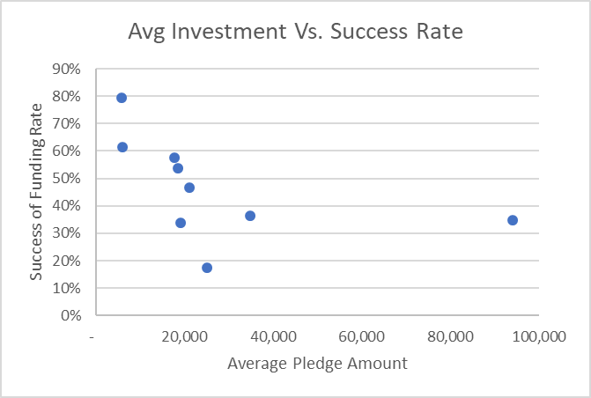

1. What are some of the limitations of this dataset?
   1. There are no metrics on ROI or profitability, so when analyzing investment choices, you really only know the total investment, duration, a blurb, and what the general category success statistic are.
2. What are some other possible tables/graphs that we could create?
   1. As seen above, I created a scatter plot to show the correlation between amount of investment sought vs success rate of receiving funding. You could bump up the success rate by project against time of year to see if there are any season trends to when and where money is being invested.